Self supporting bridge.
Leonardo da Vinci designed a famous self supporting bridge.
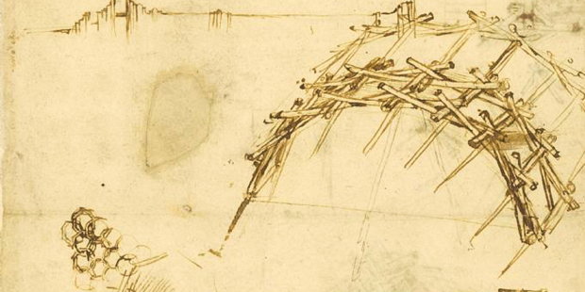
Watch one of these videos of see how it is done.
https://www.youtube.com/watch?v=QKdQV2q5PRk
https://www.youtube.com/watch?v=8sEa3MXXzw8
Your challenge today is to try and recreate this bridge at home. You can use anything you like. Large bits of wood, lolly pop sticks, lego parts, pencils, firewood, anything you have to hand, big or small.
Try and recreate the bridge and send in a photo of your bridge supporting something of weight. I will judge the bridges and award points for design, strength and quality.
If you find this too easy, try and go on and make a self supporting wooden circle using the same design.
